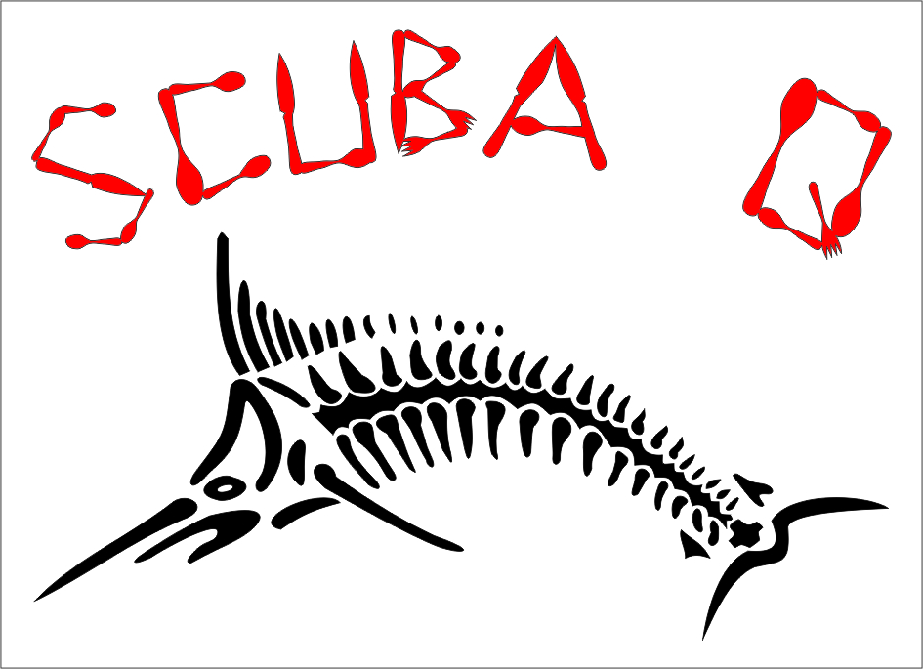
Rescue & Advance Rescue:
Duration:
Academic time: 6 hours total in the lecture room
Practical time: 10 hours in total
Course Prerequisites:
- Training and experience equivalent to NAUI Scuba Diver
- If accredited first aid CPR certification is not offered as part of the course, current certification in both is required for certification.
- If you do not have any certification, a Basic First Aid & CPR for Scuba Divers course is offered for certification. (Price R750)
Aim of the course:
This course trains divers in the knowledge and skills needed to manage risks and effectively handle limited in-water problems and diving emergencies. Included are - assists, transport, surface rescues from depth involving both boat and shore based skin and scuba divers.
Open Water dives:
At least one session is to be conducted in open water. An open water session involves one or more skin or scuba rescue exercises.
Qualification of graduates:
- Graduates are considered competent to perform assists and rescues in open water provided the diving site and diving situations approximate those of the training.
Cost:
R1500 + R160 N.A.U.I. registration fee

