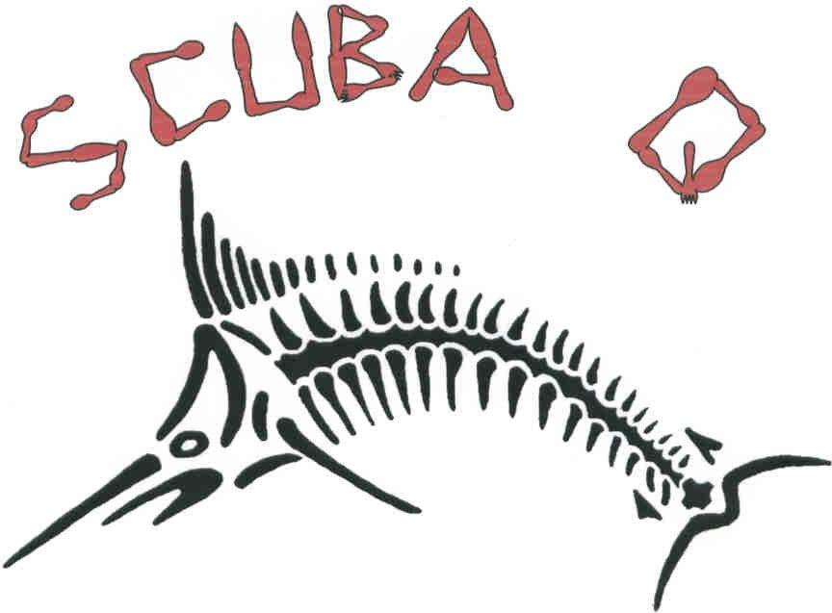

Master Diver Course!

Duration:
- Hours: 23 academic hours estimated.
This includes classroom sessions and on site discussions, briefings and debriefings as necessary to prepare for, or conclude, a dive's activity in confined water or open water.
Prerequisites for Entering the Course
- Minimum is 15 years
- NAUI advanced certificate or the equivalent is required.
- The instructor is to ensure adequate student knowledge and capability before any open water training and shall use skill or other evaluations to do so.
- Students shall furnish and be responsible for the care and maintenance of their own diving equipment. The instructor shall initially assist the student in checking all student gear to insure it is adequate and in proper working order.
Aim of the course:
- The course is a continuing education certification course for divers who wish to increase their understanding and enjoyment of diving.
- Emphasis is on student participation and practical application of knowledge in open water after a classroom discussion of subjects.
- This course is an excellent progression towards NAUI leadership roles.
Some subject areas are a review and expansion of material from previous courses.
Dives:
A minimum of eight open water dives is required.
The greatest possible variety of diving situations shall be used, such as: boat, shore or dock, lake, ocean, quarry, reservoir or river, surf or current, weeds, kelp, sand, reef, wreck, rock, mud and so on.
Required Dives:
- Search & Recovery
- Assisting an instructor with a training dive
- Deep/simulated decompression diving
- Limited visibility or night diving
- Underwater navigation
– light salvage
Elective Dives:
- Skin Diving
- Environmental study or survey
- Boat diving
- Shore diving
- Hunting and collecting
- Non-penetration wreck diving
- Photography
- Underwater exploration and mapping

Cost:
R2500 + R180 N.A.U.I. registration fee

